**Update from Cllr Derrick Louis, Essex County Council Member for Witham Southern, February 2023**

1. **Local Highway Panels**

I have been provided the following updates:

**LBRA212022 - Church Road, Hatfield Peverel – 20mph Scheme**: This is now approved for design at a cost of £5,000 and will be presented to the LHP (in March) for funding consideration.

**LBRA212029 - Main entrances to Hatfield Peverel/ Nounsley - Gateway Features & Roundels:** This is now approved for design at a cost of £8,000 and will be presented to the LHP (in March) for funding consideration.

1. **Speed Surveys**

I have arranged for speed surveys in various locations around the village to be undertaken to support existing and future LHP applications.

1. Damaged Give Way Sign

The sign below has now been replaced:

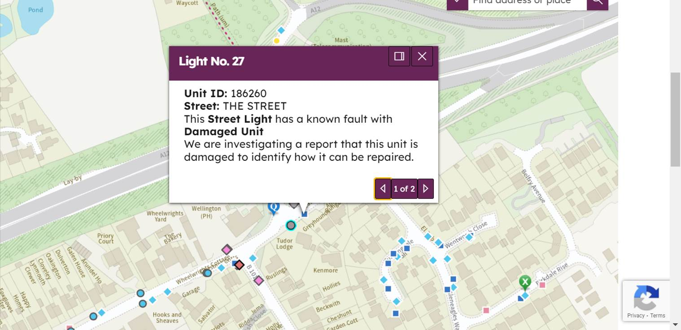

1. **Member Pothole Scheme**

These are now being progressed and for the time being any new potholes should be reported at: <https://www.essexhighways.org/tell-us> or If you think there’s a risk to public safety, do not report it online, please call immediately on 0345 603 7631.

More information on potholes, including categories and prioritisation can be found at: [Potholes - Essex County Council (essexhighways.org)](https://eur02.safelinks.protection.outlook.com/?url=https%3A%2F%2Fwww.essexhighways.org%2Froads-and-pavements%2Fpotholes&data=05%7C01%7C%7C3624c754d15442720dba08db005c1af7%7Ca8b4324f155c4215a0f17ed8cc9a992f%7C0%7C0%7C638104167800882237%7CUnknown%7CTWFpbGZsb3d8eyJWIjoiMC4wLjAwMDAiLCJQIjoiV2luMzIiLCJBTiI6Ik1haWwiLCJXVCI6Mn0%3D%7C3000%7C%7C%7C&sdata=JKQaekHmYVybh3LkLnPSo%2FSlr4fqGMEp0mfLjaSol%2Fc%3D&reserved=0)

1. **Drainage Issues**

The drains around the junction with Ulting road and Jenkings lane were jetted last weekend.

The flooding opposite the farm shop is also being investigated. The findings so far are that this is due to a collapsed pipe on private land.

1. **Changes at Recycling Centres**

I have a meeting with the Cabinet Member responsible for the decision on Wednesday to raise concerns from local residents. In the meantime, he has issued the following Q&A:

*When is the booking system being launched?*

*From Monday 13 March 2023, residents will have to book a slot in advance to visit any Essex County Council recycling centre. This is an extension of the booking system currently being trialled at Rayleigh Recycling Centre and for large vehicles at our nine van-friendly sites. The booking system will open 2 weeks in advance, on Monday 27 February.*

*Why has a booking system been introduced?*

*The booking system is being trialled to help manage waiting times, reduce offsite queues and reduce misuse of the sites by commercial vehicles.*

*Why have you waited until now to implement a booking system for all vehicles?*

*We felt it was important to trial an all-vehicle booking system at one busy site before extending the trial to all locations. Rayleigh Recycling Centre was chosen as the initial test site as the size and location of the site was causing significant queues and congestions within the area. Since the booking system was introduced, we have seen a significant reduction of queues and have received an overwhelming amount of positive feedback from residents who participated in a survey in Autumn 2022.*

*How long will the booking system be in place for?*

*The booking system will be frequently reviewed to ensure it is working efficiently, however the trial is set to be in place until December 2023. The trial will be fully evaluated in Autumn 2023. If the evaluation suggests that the introduction of a permanent booking system is under positive consideration, the council will launch a consultation on the preferred option and any alternative options. Any permanent proposals following the outcome of the evaluation and consultation will be subject to a separate decision.*

*Was there a consultation and impact assessment for this trial?*

*The booking system is an extension of the trial we already have in place for large vehicles at our van-friendly sites and all vehicles at Rayleigh Recycling Centre. The decision and impact assessment can be viewed online here* [*https://cmis.essex.gov.uk/essexcmis5/Decisions/tabid/78/ctl/ViewCMIS_DecisionDetails/mid/422/Id/9438/Default.aspx*](https://cmis.essex.gov.uk/essexcmis5/Decisions/tabid/78/ctl/ViewCMIS_DecisionDetails/mid/422/Id/9438/Default.aspx)

*The trial will be fully evaluated in Autumn 2023. If the evaluation suggests that the introduction of a permanent booking system is under positive consideration, the council will launch a consultation on the preferred option and any alternative options. Any permanent proposals following the outcome of the evaluation and consultation will be subject to a separate decision.*

*Why can I not book on the same day that I want to visit?*

*Bookings will close one day in advance to allow for detailed lists to be provided to the sites and administrative teams.*

*From 3 February, we will be trialling same-day bookings at Rayleigh Recycling Centre with the aim that this can be extended to all sites as part of the trial.*

*Do you think fly-tipping will increase now that a booking system is in place?*

*In February 2022, we introduced a booking system for large vehicles at our van-friendly sites. In May 2022, we introduced the booking system for cars at Rayleigh Recycling Centre. Since launching both booking systems, we have received no reports of increased fly-tipping incidents in the county.*

*Last year, DEFRA carried out research on the matter, and found no evidence of a correlation between introducing bookings at recycling centres and an increase in fly-tipping. Fly tipping is a criminal offence that could result in prosecution. We’d like to think that the majority of Essex residents wouldn’t turn to criminal activities just because they have to book a slot to visit their recycling centre. Residents should continue to report fly-tipping incidents to their local council, and the situation will continue to be monitored.*

*Every recycling centre is different so why have you based the trial just on Rayleigh? There’s never queues at my local recycling centre.*

*Although we recognise that all sites have different characteristics, we felt it was important to trial an all-vehicle booking system at one busy site before extending the trial to all locations.*

*Essex recycling centres have different patterns of demand and different safe operating capacity. We will reflect these differences in the number of vehicles accepted in each 15 minute slot at each site.  Bookings will be required at all sites and across all operating hours in order to prevent demand being moved from high demand locations to lower capacity sites, leading to an increase in congestion.*

*The booking system will be frequently reviewed during the trial to ensure it is working effectively and the council will make changes if needed.*

*Can I book more than one visit per day/week?*

*There is no restriction on the number of bookings you can make as long as the waste you are disposing of is household waste.*

*Why are there separate booking systems for cars and vans?*

*As vans can often take longer to unload, it is important to ensure that vans visiting the sites are spread out over the course of the day. This will help manage congestion on site and reduce queues.*

*The slots keep filling up and I’m struggling to book a timeslot. Will there be enough slots available for everyone who needs them?*

*We have a substantial network of recycling centres in Essex.  The purpose of this trial is to smooth demand across operating hours, not to reduce access.  Across the 21 recycling centres operated by Essex County Council, we will offer nearly 40,000 visits per week in summer, and nearly 35,000 visits in winter, each week.*

*The capacity of the slots is set individually for each site dependent on size and safe operating practices.  The slots will be continuously reviewed based on demand and changes can be made if needed.*

*Will I get turned away if I am slightly late to my slot?*

*We have set a 15-minute timeslot based on the average time that a resident is onsite when unloading recycling and waste from a car.  The purpose of the booking system is to help manage waiting times and reduce congestion.  If possible, please plan to arrive on-site within your 15 minute window, but we recognise this isn’t always possible.  If you have a booking and you arrive a little early or late, our staff will aim to give you access to the recycling centre as soon as there’s a space*

*Do I need to book if I am a Blue Badge holder?*

*If you are a Blue Badge holder, you do not need to book a slot to visit a recycling centre. Please remember to take proof of your Blue Badge with you when visiting these sites.*

*Do I need to book if I am a pedestrian or cyclist?*

*If you are visiting the sites as a pedestrian or cyclist (carrying your waste from your home to the site), you do not need to book a slot to visit a recycling centre. Please note, any resident that parks outside and attempts to walk waste in will be refused entry. For full site restrictions, please visit:* [*http://www.loveessex.org/news-and-ideas/recycling-centre-policy-and-site-restrictions/*](http://www.loveessex.org/news-and-ideas/recycling-centre-policy-and-site-restrictions/)

*How do I book if I can’t access the internet?*

*If residents have limited internet or accessibility issues that may restrict the from booking a slot online, there are alternative options to book. In the first instance, bookings can be made on behalf of other residents – could they receive assistance from a friend, family member, colleague, carer or neighbour?*

*They are also able to visit their local library where they can use the internet free of charge to book a slot and can also print their confirmation. Residents may also phone the Essex County Council contact centre on 0345 743 0430 Monday to Friday, 8:30am to 5:00pm who will make the booking on their behalf.*

*What if I don’t have an email address?*

*The email address doesn’t have to be personal to the resident, and it would be perfectly acceptable to supply an email address that belongs to another member of the household, a neighbour, friend, relative or carer.  So long as this can then be printed and given to them in advance of their visit, or a screenshot be taken on a mobile phone that they can bring to site with them.*

*If the booking has been made on their behalf by the Essex County Council Contact Centre, they will be advised to provide their name on arrival at site for checking against daily site bookings.*

*Decision making process*

*The booking system is an extension of the trial we already have in place for large vehicles at our van-friendly sites and all vehicles at Rayleigh Recycling Centre. The decision and impact assessment can be viewed online here* [*https://cmis.essex.gov.uk/essexcmis5/Decisions/tabid/78/ctl/ViewCMIS_DecisionDetails/mid/422/Id/9438/Default.aspx*](https://cmis.essex.gov.uk/essexcmis5/Decisions/tabid/78/ctl/ViewCMIS_DecisionDetails/mid/422/Id/9438/Default.aspx)

*The trial will be fully evaluated in Autumn 2023. If the evaluation suggests that the introduction of a permanent booking system is under positive consideration, the council will launch a consultation on the preferred option and any alternative options. Any permanent proposals following the outcome of the evaluation and consultation will be subject to a separate decision.*

*The project will be discussed with Place Services and Economic Growth Policy and Scrutiny Committee in March 2023 and we expect to further engage with Scrutiny later this year.*

 _______________________________________________________________

**If any Cllr requires help or advice, please don’t hesitate to contact me on 07967 830277 or** **cllr.Derrick.Louis@essex.gov.uk**