Footnote 16. Home Working

Office of National Statistics

Record proportion of people in employment are home workers
Part of Characteristics of Home Workers, 2014 Release
Released: 04 June 2014
Related links
- Characteristics of Home Workers, 2014
There were 4.2 million home workers in January-March 2014
There were 4.2 million home workers in January-March 2014, or 13.9% of those in work. This was the highest rate of home working since comparable records began in 1998.
Of these home workers, around 1.5 million (or 5% of those in work) worked within their home or its grounds, while the remaining 2.7 million people (8.9% of those in work) used their home as a base but worked in different places.
The number of home workers has grown by 1.3 million since 1998, at which time there had been just 2.9 million. However over the same period the number of people in work has also been rising. The percentage of those in work who work from home (also known as the home working rate) increased from 11.1% in 1998 to stand at a rate of 13.9% in January to March 2014 which is the highest than at any point in the past decade and a half.

Figure 1: Numbers of homeworkers in the UK, 1998 to 2014
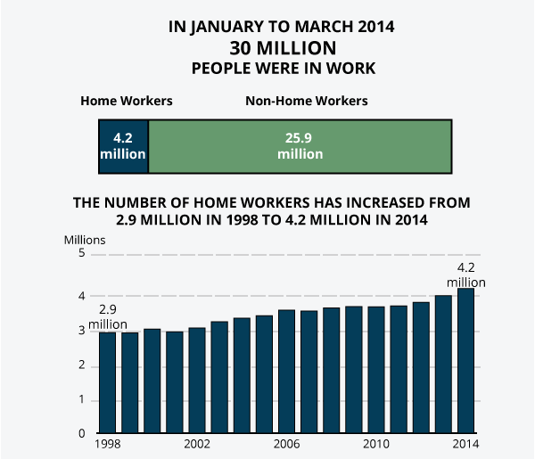
Source: Office for National Statistics

Download chart
- XLS format
(24.5 Kb)
The jobs that home workers carry out tend to be concentrated in higher skilled roles than those of people who do not work from home. Of the 4.2 million home workers in 2014, 14.8% were working as managers or senior officials, 35.2% were professionals or associate professionals and a further 23.5% were working within skilled trades. This meant that almost three quarters (73.4%) of home workers were in some of the highest skilled roles in the economy. Earnings for home workers reflect this concentration in high-skill roles, the median being £13.23 an hour compared with £10.50 an hour for other workers. For non-home workers just over a half (51.9%) were among the same occupational groups. The most common roles for male home workers were among construction occupations, while for women the top roles included childminding and care work.
People working from home are more likely to be self-employed than non-home workers. In January to March 2014, around 7% of non-home workers were self-employed compared with 63% of home workers. Around 34% of home workers were employees of an organisation, with the small remainder being people who worked unpaid in the family business.
Working from home is more prevalent among individuals who are older. For those aged 16 to 24 the home working rate stood at 5.1%, compared with 13.9% for all workers, while for those aged 65 and over, it was 38.3%. With the exception of the oldest age group (65 and over), home workers were more likely to use their home as a base rather than work within the grounds of their home. For the oldest age group they are less likely to be working within construction type roles which reduce the numbers working from home and using it a base when compared to those who work within their grounds.
Across 2013 as a whole, the South West was the region of Great Britain with the highest home working rate at 17.1%, while the lowest rate was in Scotland at 10.7%. As at the 2011 Census, the local area with the highest home working rate across England and Wales was West
Somerset, at 25.7%, while the lowest was Kingston upon Hull, at 5.2%.

Figure 2: Home working rates by regions across Great Britain
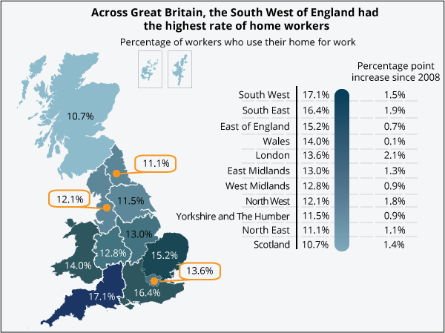
Source: Office for National Statistics

Download chart
- XLS format
(33 Kb)
Categories: Labour Market, People in Work, Employment, Employment Type, Home Working

